Digital Marketing Measurement Model

Alejandra Barrios– 301314502
Paula Carrillo – 301314500
Sebastian Gonzalez – 301336125
Saksham Tiwari- 301334725

Centennial College
Digital Marketing Analytics
Rohan Chandarana
January 28, 2024

Executive Summary
The objective of this report is to provide the Digital Marketing Measurement Model (DMMM) for Google Merchandise Store that establish the goals, KPI, target, and audience segments for February 2024. The data used to build the DMMM is from the Google Analytics demo account.
The report is divided into three main sections that are Data Analysis, DMMM, and Actions. The first part of the report gives a comprehensive overview of the patterns within the user lifecycle including acquisition, engagement, and monetization. This analysis allowed to have the insights for the formulation of the goals, KPIs, targets, and segments of the DMMM that are explained on the second part of the report. Finally, the last section of the report offers actionable recommendations for the Google Merchandise Store in terms of marketing budget, campaigns, and user experience.

Data Analysis
In this section, we delved into the available data within Google Analytics demo account to identify trends and seasonality in users, goals, and KPI. For this part we focused on the previous year January to December 2023; additionally, we also considered the months of November 2022, December 2022, and January 2024.

Acquisition
In the past year, total revenue reached $1,806,757.61, with the Direct channel leading at $1,325,009.64, comprising 73.34% of the total revenue. Organic Search contributed 16.82%. ($304,074.12), and Email contributed 3.2% ($57,890.84) (Figure 1). Throughout November and December 2022, Direct, Organic Search, and Email consistently contributed 63.32%, 21.75%, and 5.9% respectively. In January 2024, those two channels remain the primary contributors with 81.25% for Direct, 8.16% for Organic Search, and 4.21% for Email.
Google Merchandise Store acquired 789,894 new users last year, with Direct, Organic Search, and Cross-network leading at 42.06%, 25.35%, and 22.64% respectively (Figure 2). The three main channels that helped to gain most new users during November to December 2022 were Direct (50.78%), Organic Search (26.24%), and Display (9.07%); however, the Display channel did not contribute to the revenue.

Engagement
We divided this section into four parts, as a part of the user’s purchase journey, starting with the user viewing the product and ending by adding the payment to finalize the purchase. The following are the micro conversion a user must go through to achieve the macro conversion of complete a purchase:
- View product: the total number of views last year was 6,722,360 with 15,448 events of purchase; Apparel and lifestyle were the top predominant pages section that potential customers searched on the website with 19.85% and 9.37% of the total of views respectively (Figure 3). This matches the total revenue per item category; Apparel has the highest revenue with 31.91% of the total revenue last year as well as lifestyle being in the fifth position with 5.62% of the total revenue. Although the Shop by Brand page section had 3.66% of the total views, it is an important item category to consider since it has the 15.82% of the item revenue.
- Begin checkout: 10,026 users started a checkout last year out of the 250,906 users who view a product, which means the step from viewing a product to beginning checkout had an abandonment rate of 96%. 7987 users begun the checkout through desktop with is equivalent to 79.66% of the total users, and mobile with 19.59%.
- Add shipping: 8,558 users added the shipping information last year out of the 18,206 users who began the checkout with an abandonment rate of 53% between each step. 6,887 users did the purchase process through desktop with is equivalent to 80.47% of the total users, and mobile with the 18.82%.
- Add Payment: 7,108 users went through the payment step last year out of the 8,558 users who added shipping information, with an abandonment rate of 16.9%. 5,869 users did the purchase process through desktop with is equivalent to 82.57% of the total users, and mobile with 16.73%.
According to the data, there is less abandonment rate between adding the shipping information and the payment information, meaning that approximately 84% of the users who add shipping information end up completing the purchase. In the contrary, beginning the checkout just guarantee 47% of the users complete the purchase.

Monetization
As mentioned, the revenue for 2023 was $1,806,757.61. The top three products that led the revenue generation were the Super G Timbuk2 Recycled Backpack at $48,075, the Google Unisex Eco Tee Black at $30,533.20, and the Google Black Eco Zip Hoodie at $29,808. The top three products that led the 2023 by number of items purchased were Google Pen at 3,760, Google Cloud Sticker at 3,641, and Google Sticker at 2,855. (Figure 4).
An important thing about monetization is to understand at which point of the transaction the users went to. The abandonment rate shows us how many users abandon at a certain point in the transaction. These were the abandonment rates for each of the steps after the session started 68.7%, view product 84.2%, add to cart 74.7%, and begin checkout 54.2%. Only 45.8% of the users that went to checkout purchased at the Google Merchandise Store. Of 802,000 users that started the session, only 4,600 bought something in the store. (Figure 5).

Digital Marketing and Measurement Model
Google Merchandise Store
Acquisition
Behavior
Website Goal
Increase new users
KPI
# of new users
Target
18,044/Month
Segments
Channel
Region
Website Goal
View product
KPI
#views on screen website
Target
14065/Month
Segments
Item Category
Page Section
Website Goal
Begin checkout
KPI
# of users that begin checkout
Target
1034/Month
Segments
Device Category
Region
Website Goal
Add shipping information
KPI
# of users that fill shipping information
Target
835/Month
Segments
Device Category
Region
Website Goal
Add payment information
KPI
# of users that add payment information
Target
754/Month
Segments
Device Category
Region
Outcomes
Website Goal
Make a purchase
KPI
Revenue
Target
$ 77,868 /Month
Segments
Item category
Region
For the month of February 2024, we propose to focus on the following goals:
- Increase new users to the website: our priority is to boost the website by targeting new users, as they comprised 86% of the total users last year. The KPI for this objective is the number of new users, with a target set at 18,044, derived from analyzing growth trends (Figure 6). Using the decline rate of 11.65% and the base line of new users in January 2024, which amounted to 20,423. Regarding the segments, we will concentrate on two key areas for this goal: channels and regions. We will focus on the top three revenue-generation channels (Direct, Organic, and Email) and five regions with the highest purchasing users (California, New York, Texas, Washington, and Illinois).
- View product: the goal is users to view products on the website. The KPI for the objective is the number of views on the website, with a target of 14065 views per month. The target was chosen by estimating the growth rate of the past months (November, December, and January), and considering the trends over the year (Figure 7). Based on January and February 2023, the number of users viewing products increased in 1.29%, which is equal to 14,065 views. For the segments, concentrate on item category and page section, particularly on apparel, lifestyle, and Shop by Brand, as they represent the top three segments in terms of both revenue and views.
- Begin checkout: The micro-conversion goal is for users to initiate checkout with KPI focused on the count of users starting the checkout process. It is projected for 1034 users in February based on the trends and growth rate. The Segment is based on the device category - Desktop and Mobile which are the most frequent, and also the region prioritizing California, New York, Washington, and Texas as key regions where users initiate purchases.
- Add shipping information: the goal is users to enter the shipping information and the KPI is the number s users who add shipping information with a target of 835 users in February. The segmentation will be the device category and Region which is the same as the begin checkout, since this micro conversion is related to the process of purchase, the following action of shipping information will also be from the same device.
- Add payment information: the goal is users to enter the payment information and the KPI is the number of users who add payment information with a target of 754 users in February, and the segmentation will be the device category and Region.
- Complete a purchase: the macro conversion for Google Merchandise Store is completing a purchase, with a KPI being revenue. The targeted revenue for February 2024 is US $62,647.03. This objective was derived from January 2024 total revenue of $77,591.30 (Figure 8), calculations involve applying a growth rate of -19.26%, reflecting the revenue change from January 2023 to February 2023. For the two segments, we will focus on Item Category (specifically Apparel, New, and Shop by Brand) and Region (specifically California, New York, and Texas), representing the top three contributors to 2023 revenue (Figure 9 and Figure 10).

Actions
We would like the Google Merchandise store to consider our proposed DMMM and take action in following manner to achieve the targeted revenue for February 2024:
- Increase New Users:
  - Action: Allocate budget to targeted campaigns on Direct, Organic, and Email channels.
  - Focus: California, New York, Texas.
  - More email newsletters to be sent updating users with new items in store and theme-based products.
- Viewing product (14,065/month):
  - Highlight top sellers, curated collections in Apparel, Lifestyle, Shop by Brand.
  - Personalize product recommendation based upon previous purchase.
  - Include monthly theme-based products for February Valentine’s Day, Chinese New Year, and World Cancer Day.
- Begin Checkout (1034/month) – Reduce Checkout Abandonment (96%):
  - Offer guest checkouts.
  - Show shipping fees and taxes upfront to keep cost transparency by asking postal code while viewing product.
  - Target users who leave carts abandoned through email reminders.
- Shipping information (835/month) - Reduce abandonment (53%)
  - Reduce frictions points by combining shipping and payment in one page.
  - Give autofill options to reduce time filling address information.
  - Improve user-interface while entering shipping information.
- Adding payment information (754/month):
  - Offer multiple payment options.
  - Offer guest checkout.
  - Combine with shipping information page to reduce time.
- Budget allocation to focus on following areas:
  - Sending more email newsletters to show new products and theme-based products.
  - Collaborate with influencers, niche technology community as Google will closely relate to it.
  - Further optimize SEO for relevant keywords driving organic search sales higher.
The proposed key to success depends on data driven decision, continuous optimizing and testing the website to improve display sales while leveraging on tailored campaigns.

Appendix
Figure 1. Revenue 2023 by Channel
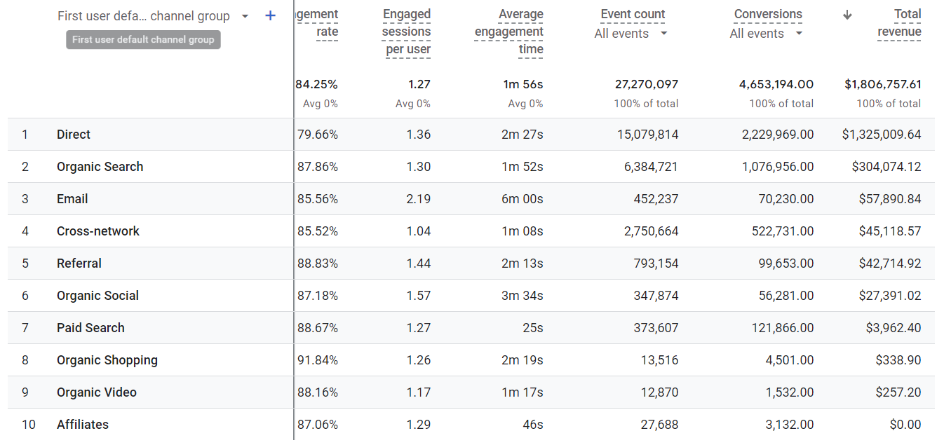
Figure 2. New Users 2023 by Channel
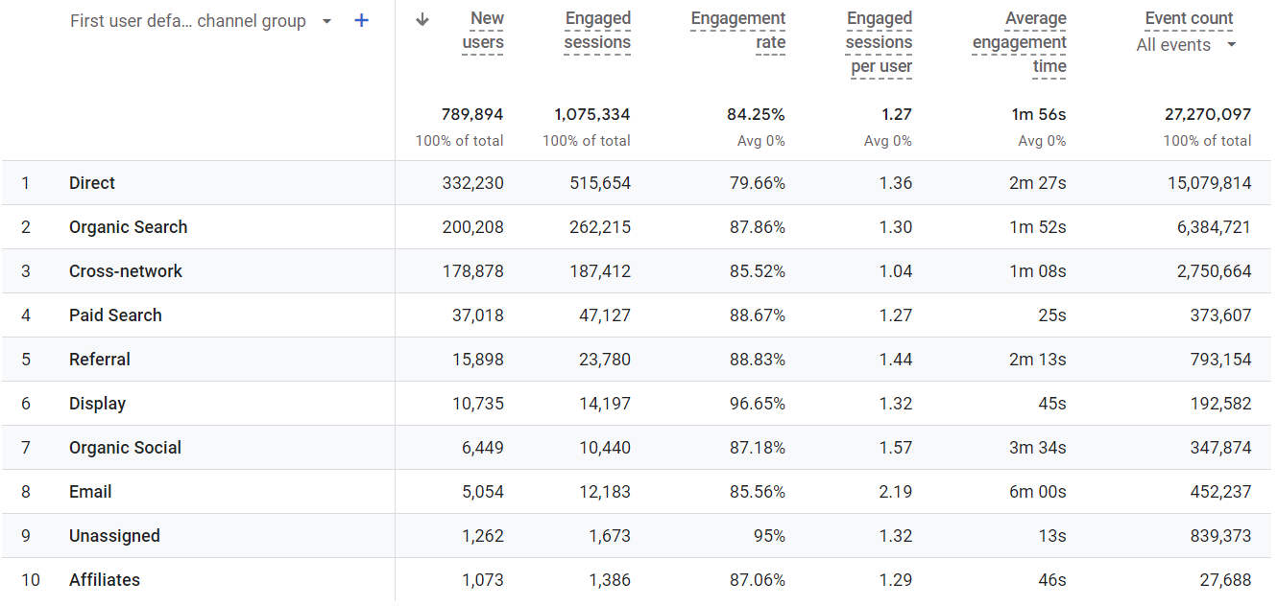
Figure 3. Number of views by Page Section
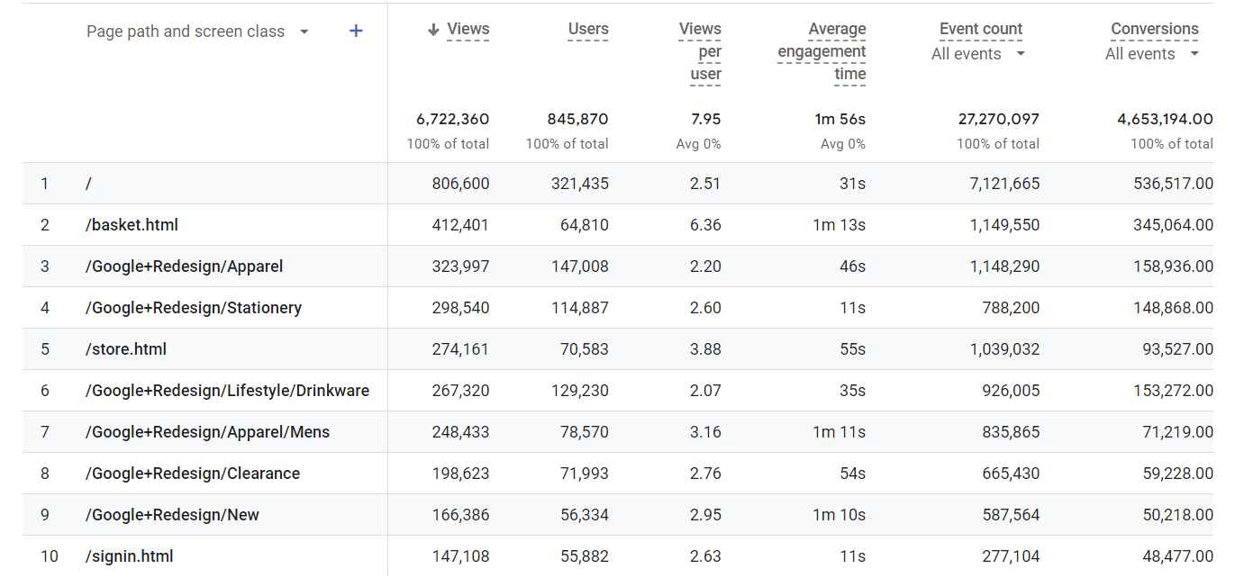
Figure 4. New Users Growth Rate
Year | Month | New Users | Growth Rate
2022 | November | 22,061
2022 | December | 90,920 | 312.13%
2023 | January | 67,092 | -26.21%
2023 | February | 59,278 | -11.65%
2023 | March | 50,926 | -14.09%
2023 | April | 66,238 | 30.07%
2023 | May | 60,737 | -8.30%
2023 | June | 56,450 | -7.06%
2023 | July | 62,487 | 10.69%
2023 | August | 73,530 | 17.67%
2023 | September | 97,054 | 31.99%
2023 | October | 61,894 | -36.23%
2023 | November | 61,806 | -0.14%
2023 | December | 72,357 | 17.07%
2024 | January | 20,423 | -71.77%
2024 | February | 18,044* | -11.65%
*Number of users calculated based on the growth rate from January 2023 to February 2023 and number of users from January 2024.
Figure 5. Revenue 2023 by Product
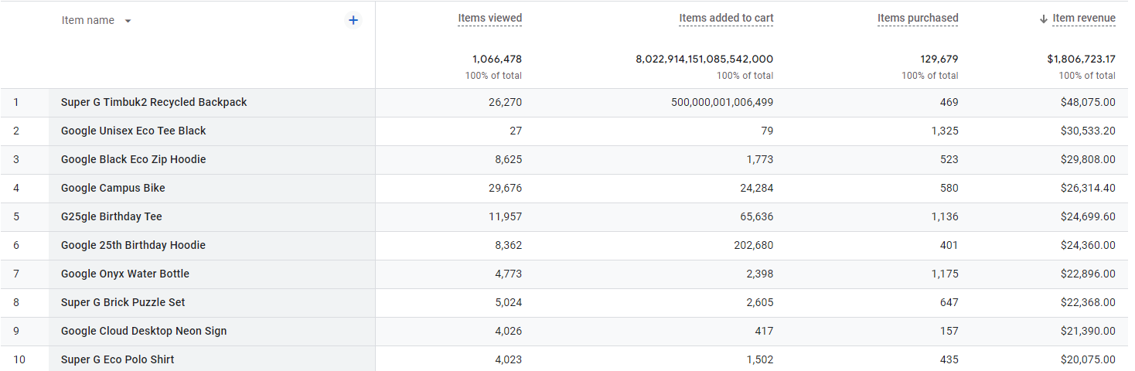
Figure 6. Items Purchased 2023 by Product
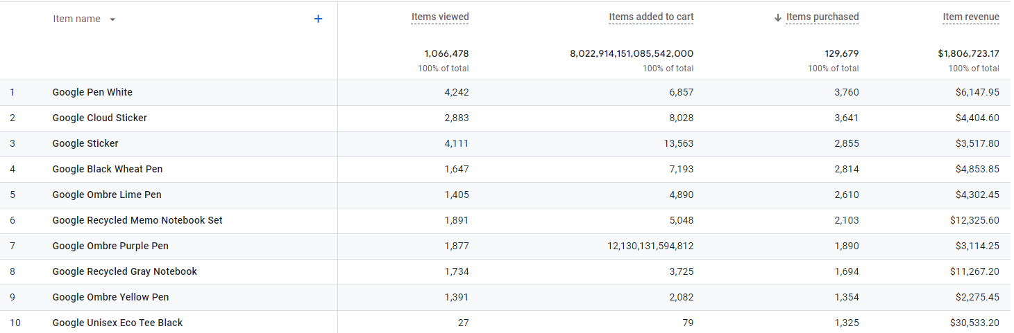
Figure 7. Revenue Trend 2023 per month
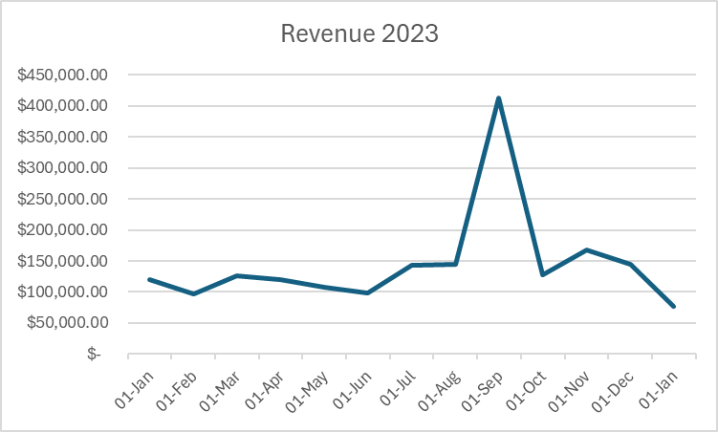
Figure 8. Revenue Growth Rate
Year | Month | Revenue | Growth Rate
2022 | November | $ 120,918.92
2022 | December | $ 262,535.13 | 117.12%
2023 | January | $ 119,449.76 | -54.50%
2023 | February | $ 96,443.45 | -19.26%
2023 | March | $ 125,696.78 | 30.33%
2023 | April | $ 120,483.46 | -4.15%
2023 | May | $ 108,152.42 | -10.23%
2023 | June | $ 98,750.03 | -8.69%
2023 | July | $ 142,778.42 | 44.59%
2023 | August | $ 143,962.00 | 0.83%
2023 | September | $ 411,827.17 | 186.07%
2023 | October | $ 126,967.20 | -69.17%
2023 | November | $ 167,420.33 | 31.86%
2023 | December | $ 144,792.25 | -13.52%
2024 | January | $ 77,591.30 | -46.41%
2024 | February | $ 62,647.03* | -19.26%
*Revenue calculated on the Revenue from January 2024 based on the growth rate from January 2023 to February 2023.

Figure 9. Revenue 2023 by Item Category
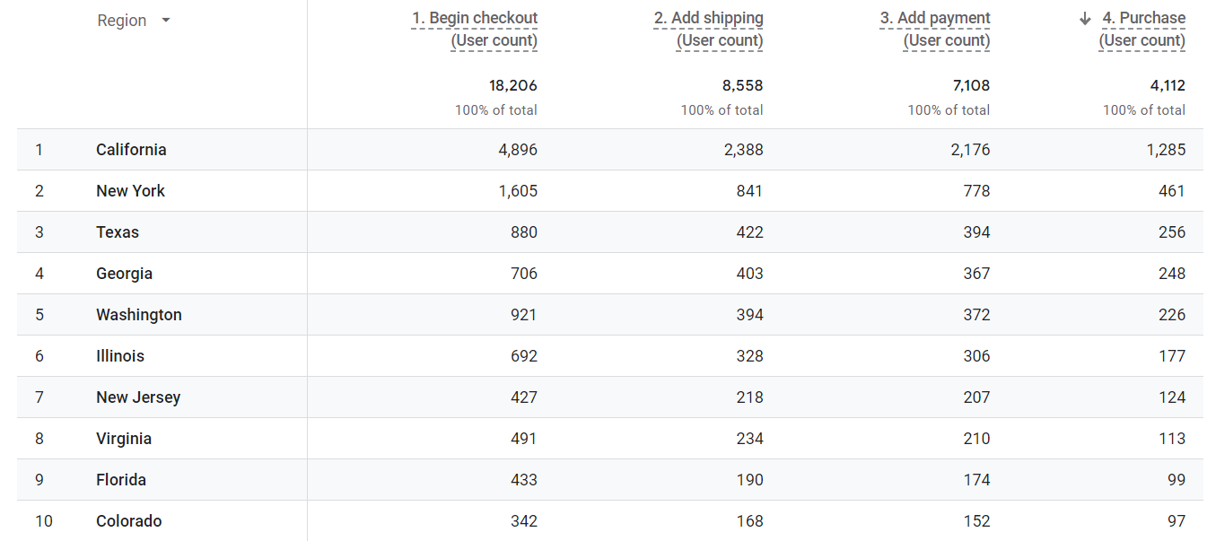
Figure 10. Number of purchases 2023 by Region